PURCHASE AND INSTALL MICROSOFT WORD
VERSION 2013 OR LATER AND THE FORM TOOL PRO

To purchase Perfect Legal Pleadings go to
https://www.perfectlegalpleadings.org/subscribe
The Perfect Legal Pleadings system consists of three programs: (1) Microsoft Word 2013 or later; (2) The Form Tool Pro; and (3) Perfect Legal Pleadings. Microsoft Word is a computer word processor. The Form Tool Pro is a document assembly program that runs on Microsoft Word. Perfect Legal Pleadings contains thousands of Oklahoma legal pleadings and forms that are constructed to run on Microsoft Word by use of The Form Tool Pro document assembly program.
Click Here to Purchase and Install TheFormTool Pro
Once you have Microsoft Word and TheFormTool Pro installed, follow the instructions below to purchase, download an install Perfect Legal Pleadings.

DOWNLOAD AND INSTALL INSTRUCTIONS
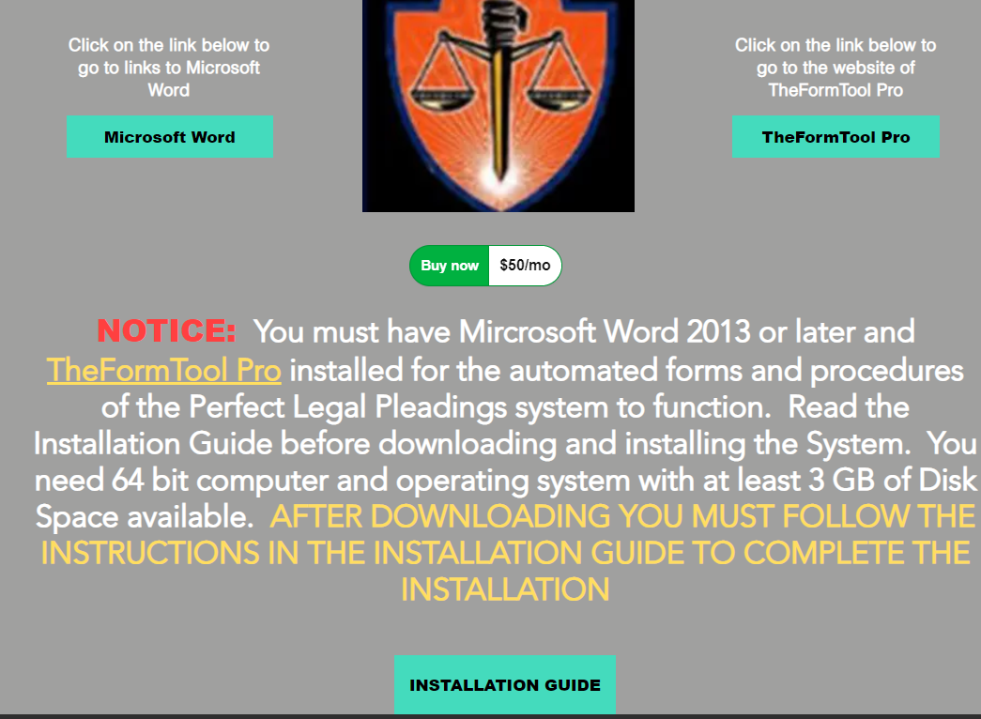

First click on the “Buy Now” button. Then the screen below will appear.
Now click on “Buy subscription” and the screen on the next page will appear.

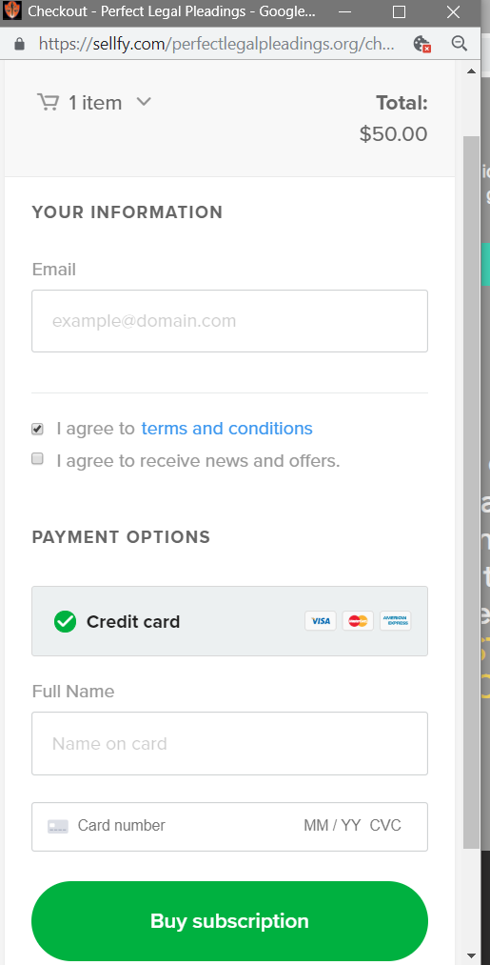

IMPORTANT
Be sure that “I agree to
Receive news and offers” is
Checked so that you will
Receive emails with updated
Versions.

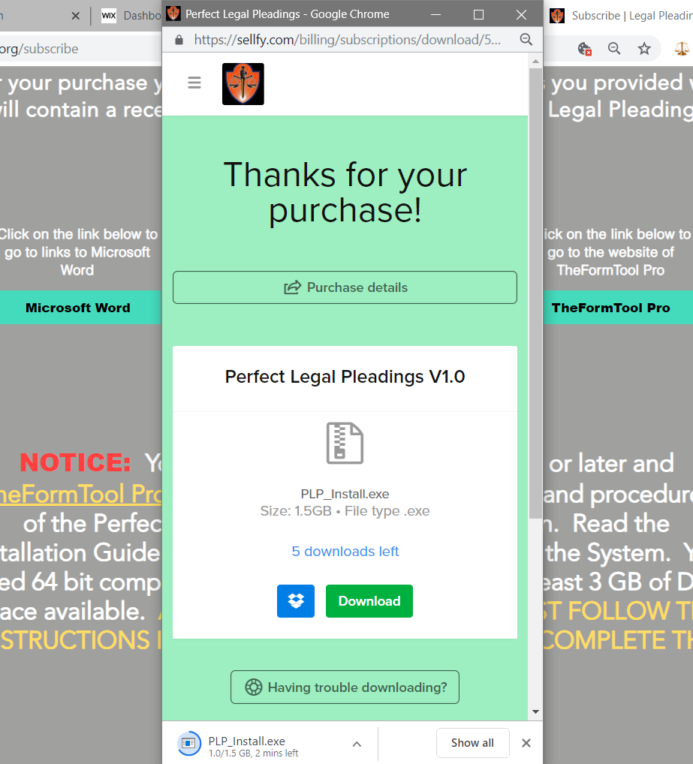
No enter your email address and click on “I agree to terms and conditions” and input your credit card information and click on the “Buy subscription” button. Then the screen below will appear. Click on “Download” in the screen below and the Perfect Legal Pleadings program will begin installing and you can watch it’s installation progress in this area.

In addition to the screen on the preceding page you will also receive an email similar to the one below that you can also download the Perfect Legal Pleading program from.
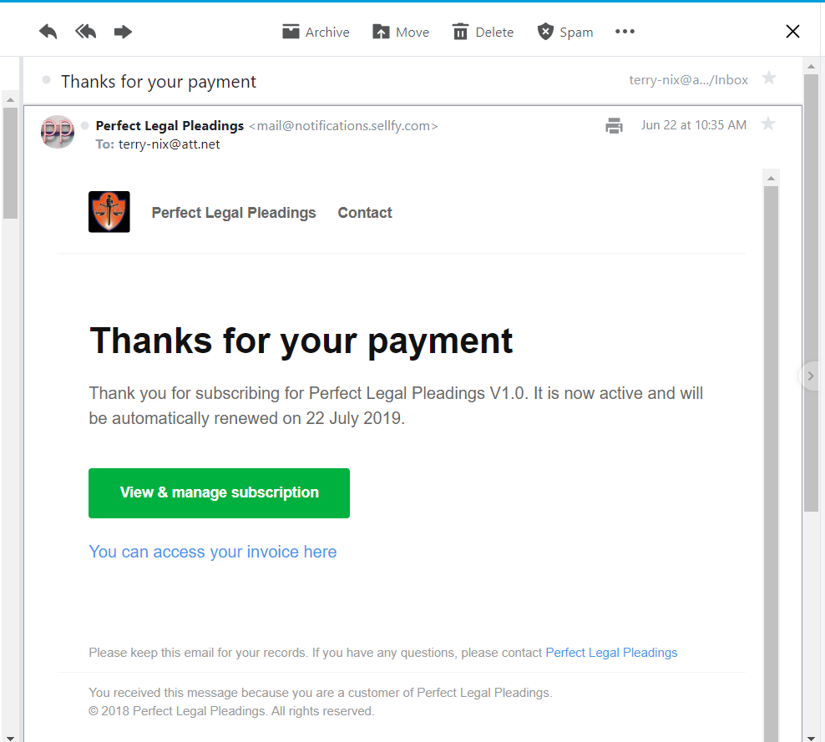

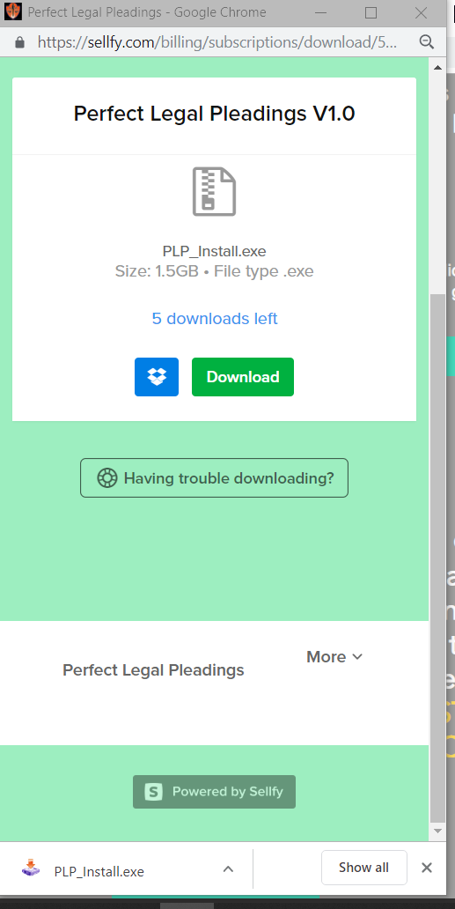
Once the Perfect Legal lPleadings program is completely downloaded the screen should appear as depicted below. NOTICE: This signifies that the download is complete.

Now click on “PLP_Install.exe” or
“PLP.exe”, whichever appears
and the screen on the next page
Will appear.
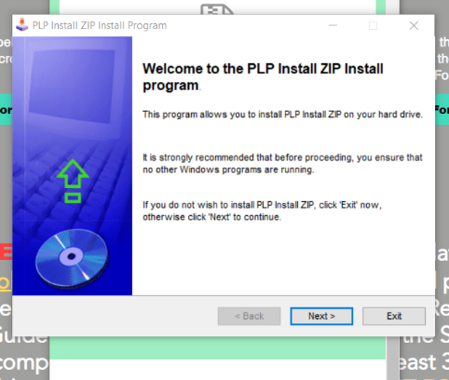

Now click on “Next” and the page below will appear.

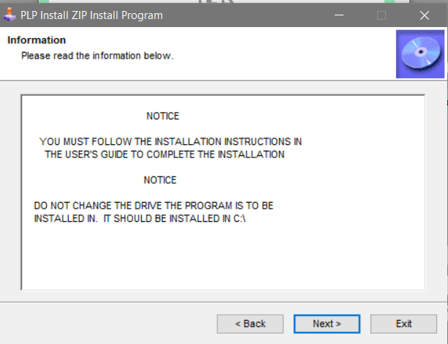

Now click on “Next” and the screen on the following page will appear.

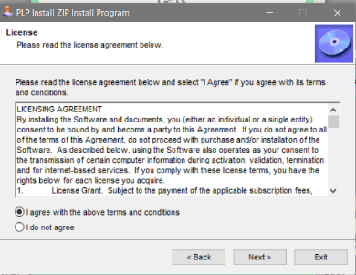

Now click the “I agree with the above terms and conditions” so that it is selected (black) and then click “Next” and the screen below will appear.
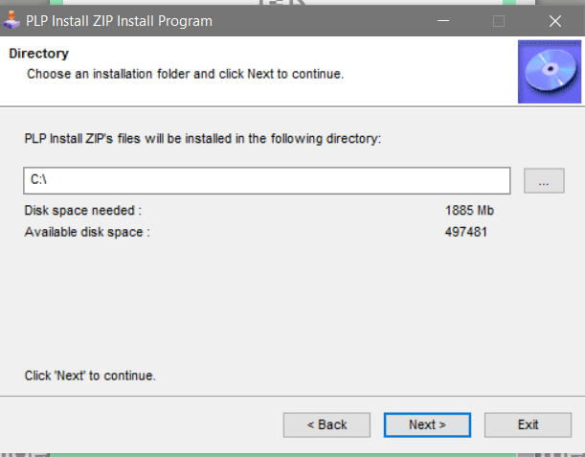

DO NOT CHANGE THE LOCATION OF INSTALLATION. LEAVE IT AT “C:\”
Now click on “Next” and the screen on the following page will appear.

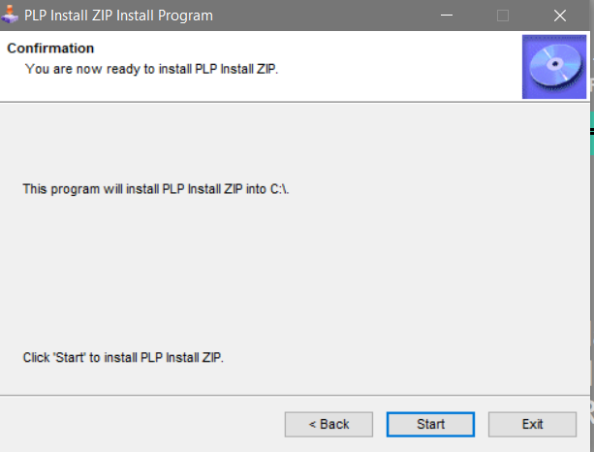

Now click on “Start” and the screen below will appear.
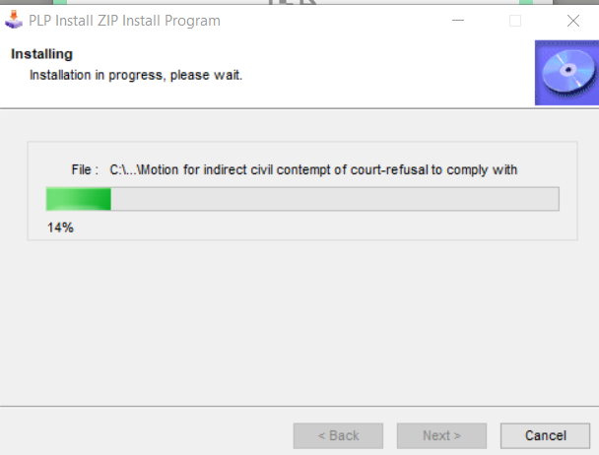

This will display the progress of the download. Once it turns completely green across the bar it has completed the download and will show the screen on the following page.

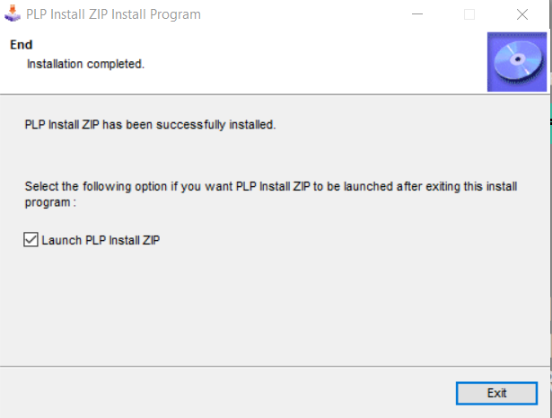

Be sure the “Launch PLP Install” is selected and then click “Exit”. Then the screen on the next page will appear.

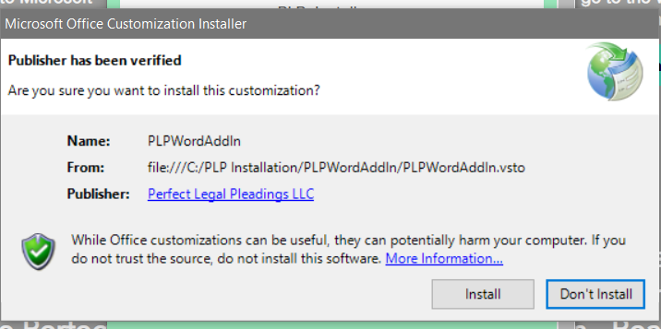

Now click on “Install”.
If you get an error message similar to the one below, then follow the instructions below (Pages 10 through 19) to fix the problem. If you don’t get the error message below then proceed to page 19 to continue the installation and setup.
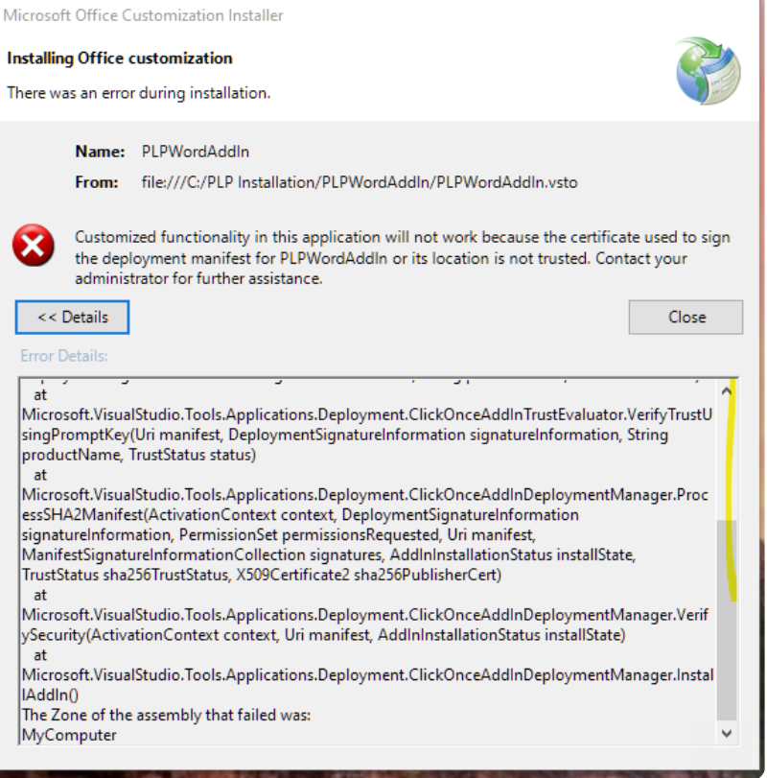

Now when you start Microsoft Word there should be a tab in the control ribbon at the top of the screen that is entitled, “Perfect Legal Pleadings”. Click on this tab to access the Perfect Legal Pleadings program. NOW YOU NEED TO FOLLOW THE INSTRUCTIONS BEGINNING AT PAGE 19 TO COMPLETE THE INSTALLATION PROCESS. This includes changing the folder where the Masterlist of TheFormTool Pro is stored.
Sometimes when someone attempt to install Perfect Legal Pleadings they get an error similar to that depicted below. To fix this problem and complete the installation fo Perfect Legal Pleadings, follow the instructions below.

Follow the instructions on the following pages to work around the above error message.

HOW TO INSTALL PLPWORDADDIN
IF ERROR OCCURS DURING INSTALLATION

At the bottom of your computer screen click on the file icon to open your file manager.

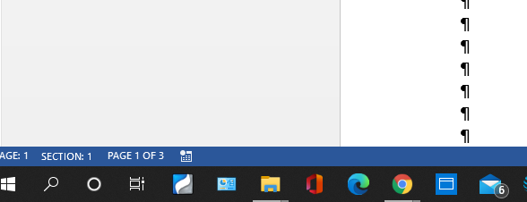

Once you click on the file icon, the screen below will appear.
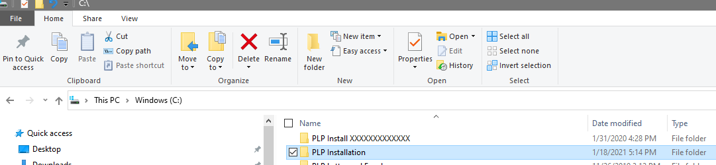

Now go to the folder labled “PLP Installation”. You will find it on your “C” drive. The address is C:\PLP Installation.
Now double left click your mouse on the folder “PLP Installation” and the screen on the next page will appear.

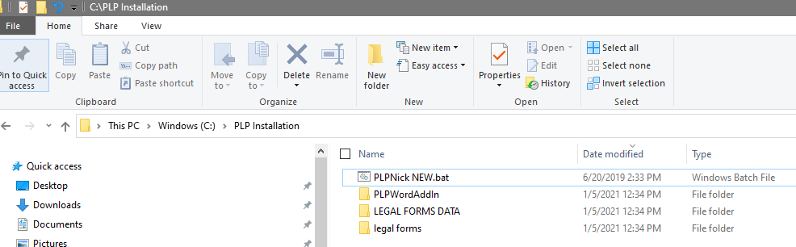

Now double left click your mouse on the folder “PLPWordAddin” and the screen below will appear.

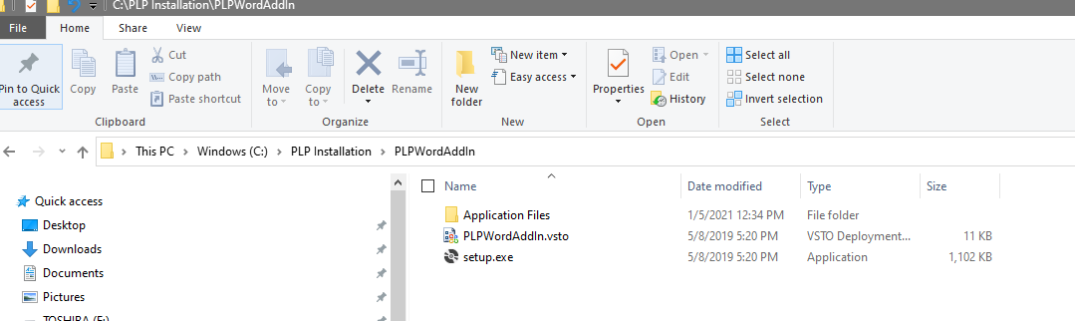

Now place your cursor on the file “setup.exe” and RIGHT click your mouse and a drop down list will appear. In the drop down list click on “Properties” and the screen below will appear.
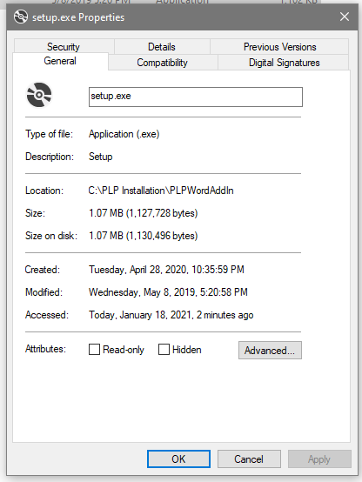

Now click on “Digital Signatures” and the screen on the next page will appear

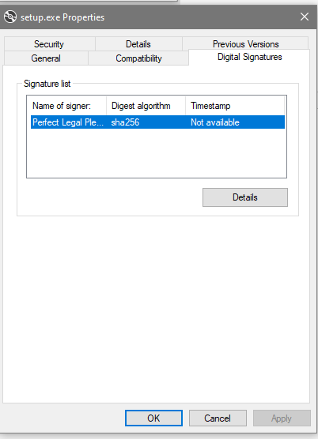

Now Click on “Perfect Legal Pleadings” in the Signature list. Once you click on “Perfect LegL Pleadings” the line containing that phrase will be highlighted in blue as depicted to the left.

No click on “Details” and the screen below will appear.

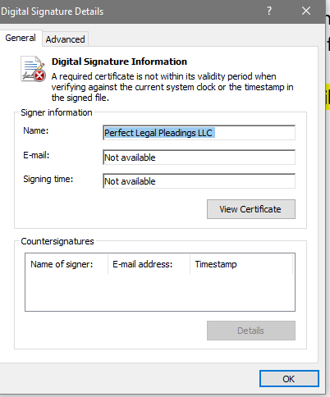

Now click on “View Certificate” and the screen on the next page will appear.

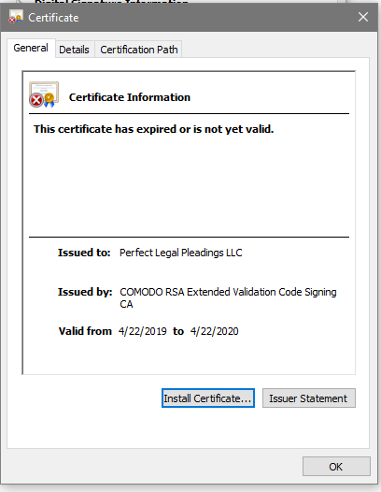

Now click on “Install Certificate” and the screen below will appear.
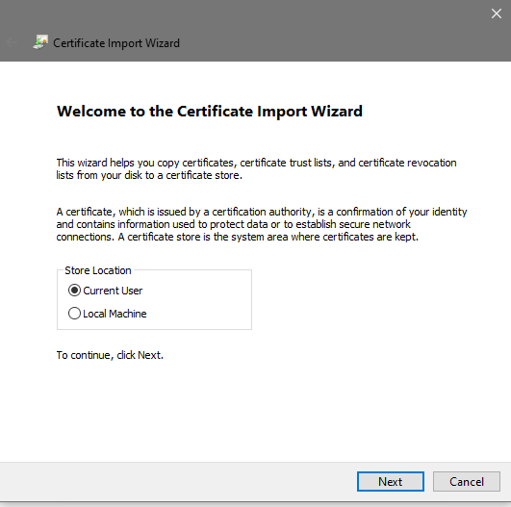

Make sure “Current User” is selected and then click on “Next” and the screen on the next page will appear.

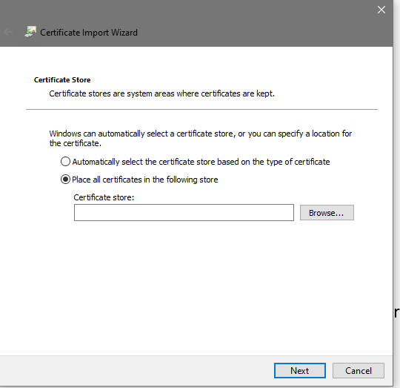

Make sure
“Place all certificates in the following store” is selected.

Now click on “Browse” and the screen will appear as depicted below.

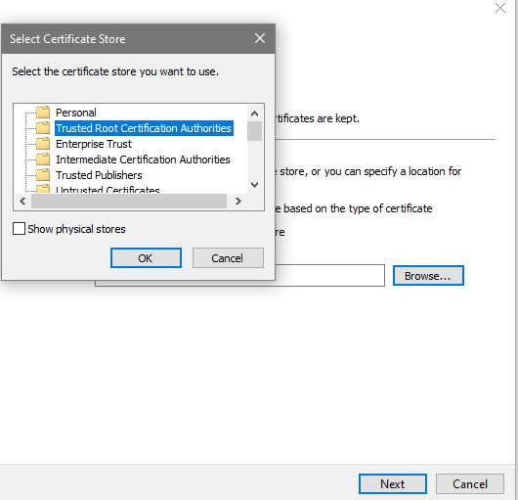

Make sure “Trusted root Certification Authorities” is selected (highlighted in blue). Select it by clicking on it.

Then click on “OK” and the screen on the next page will appear.

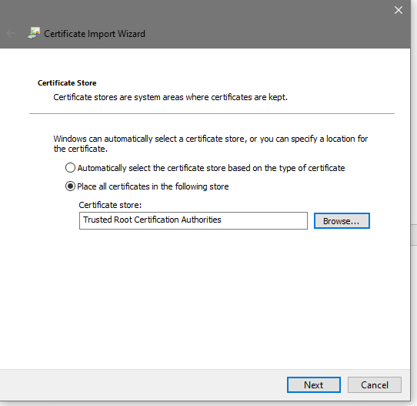

Now click on “Next” and the screen below will appear.
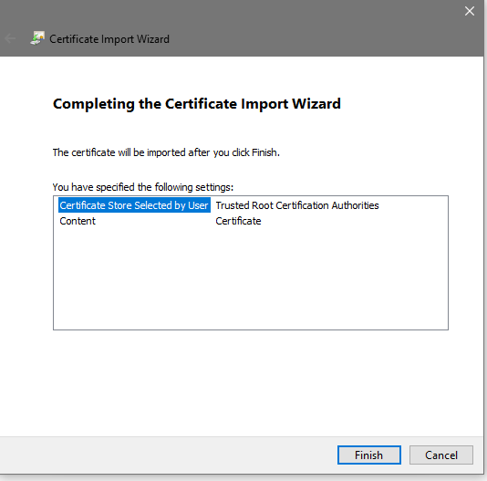

Now click on “Finish”.

Now follow the instructions on the following pages to install the PLPWordAddin.

At the bottom of your computer screen click on the file icon to open your file manager.

Once you click on the file icon, the screen below will appear.

Now go to the folder labled “PLP Installation”. You will find it on your “C” drive. The address is C:\PLP Installation.
Now double left click your mouse on the folder “PLP Installation” and the screen on the next page will appear.

Now double left click your mouse on the folder “PLPWordAddin” and the screen below will appear.

Now place your cursor on the file “setup.exe” and RIGHT click your mouse and a drop down list will appear. In the drop down list click on “Run”, “Run as Administrator”, or “Open” and the PLPWordAddin Screen below should appear.

Now click on “Install” and the screen on the next page will appear.

Now when you start Microsoft Word there should be a tab in the control ribbon at the top of the screen that is entitled, “Perfect Legal Pleadings”. Click on this tab to access the Perfect Legal Pleadings program. NOW YOU NEED TO FOLLOW THE INSTRUCTIONS ON THE FOLLOWING FEW PAGES TO COMPLETE THE INSTALLATION PROCESS. This includes changing the folder where the Masterlist of TheFormTool Pro is stored.
CHANGE DATA STORAGE FOLDER.

Now you need to change the folder where the data is stored. To do this, open the TFT Control Ribbon by clicking on TheFormTool tab in the Word Control Ribbon.

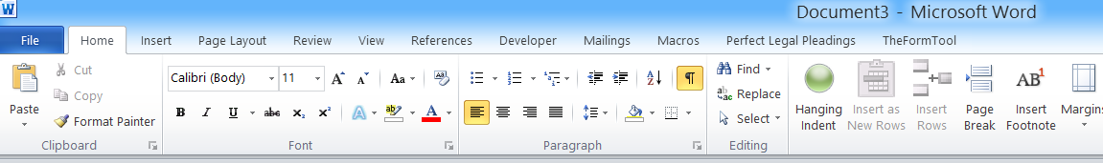

Once you click on the TFT tab in the Word Control Ribbon the following TFT Control Ribbon will appear.

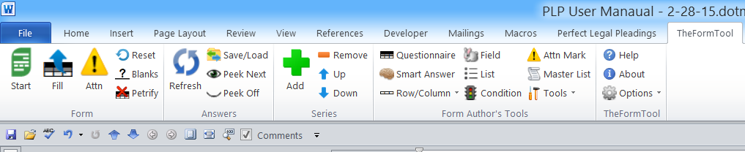

In the TFT Control Ribbon click on “Options” command. A drop-down list of choices will appear. Select “Path” from the drop-down list that will appear after you click “Options”.

Holidays
License code
License agreement
Path
Uninstall

Once you have clicked on the “Options” command in the TFT Control Ribbon and selected “Path” from the drop-down list, the following dialogue box will appear.

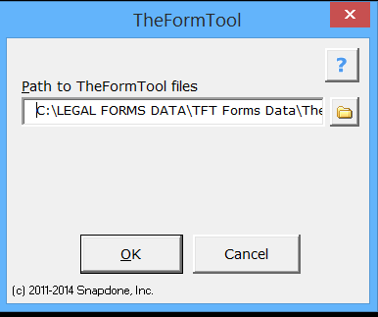

You MUST change the “Path to TheFormTool files.” Delete the contents in the data field and change the path to the following:

C:\LEGAL FORMS DATA\TFT Forms Data

CAUTION: You must TYPE the above path in the box. DO NOT use the folder icon to select the path.

SET HYPERLINK CONTROL: You may already have your hyperlink control in Word set where you can just click on a hyperlink to open it. Otherwise, to execute a hyperlink in Word you must hold down the CTRL key and left-click your mouse on a hyperlink. If your hyperlink setting in Word is not already set where you can just click on a hyperlink to open it, then you will need to change this in Word. To check your hyperlink setting in Word or to change it follow the instructions below:
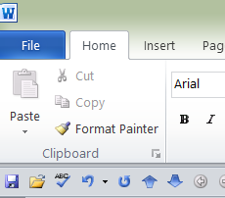

First, click on “File” in the Word Command Ribbon (tool bar). Then the screen below will appear.

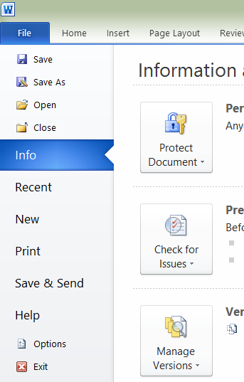

Second, click on “Options” in the screen to the left. Then the screen on the following page will appear.

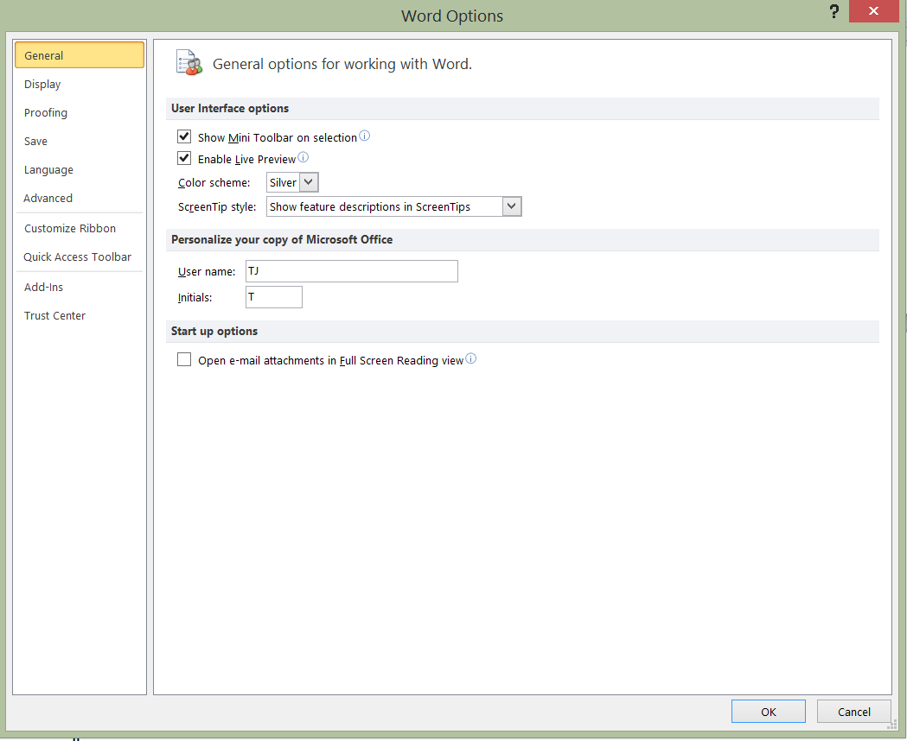

Fourth, make sure “Use CTRL + Click to follow hyperlink” is NOT CHECKED (make sure box next to these terms is empty). If it is checked, then uncheck it.

Third, click on “Advanced” in the screen above. Then the screen below will appear.

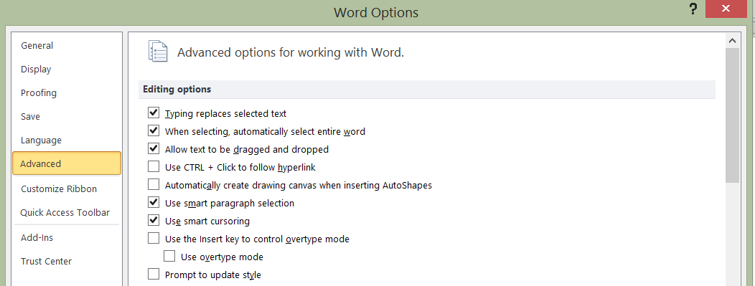

SET ORIGINAL FORMS TO “READ-ONLY”. To protect your original Perfect Legal Pleadings forms from being overwritten accidentally, you need to set the forms folder to a “read-only” folder. The forms folder is labeled “legal forms” and is found on your C drive (C:\legal forms). To set the legal forms folder to read-only complete the following steps:

First, open the file manager by clicking on this icon in the bottom of your computer screen.

Once you have clicked on the file manager icon, the screen below will appear. Now go to the C drive by double left clicking your mouse here
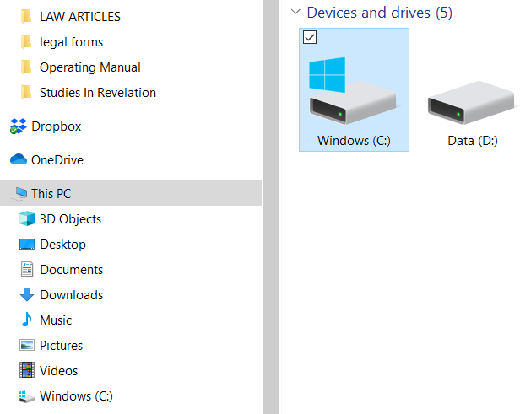
Once you click on the “C” drive icon above, the screen on the following page will appear.

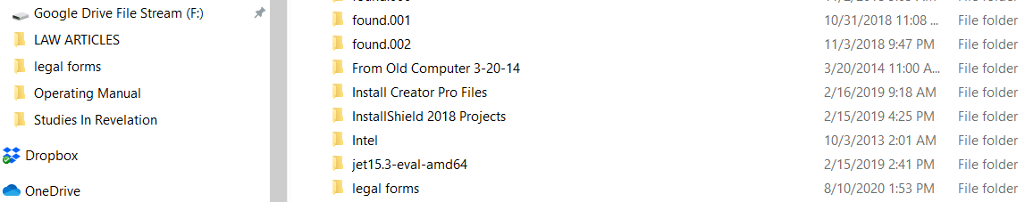

Now place your cursor on the folder “legal forms” and right click your mouse. A drop down list will appear. At the bottom of the list is “properties”. Left click on “properties”. When you click on “properties” the following screen will appear. Make sure the attributes is set to “Read only”. Make sure “Read only” is checked.
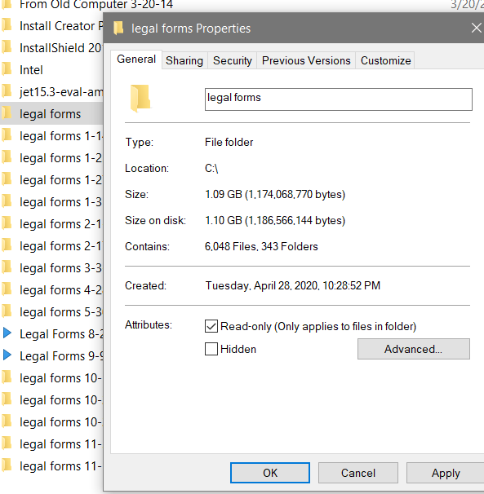

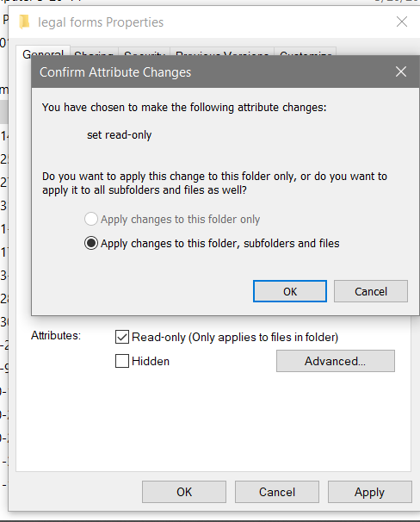
Now left click on “Apply”. Then the following will be displayed. Make sure “apply changes to this folder, subfolders and files” is selected and then click on OK.

